PNR: 260740150018
Name: PRATIK SUNIL ABHANG

Question 1: VLAN
Configure VLAN 10 and VLAN 20 on Switch1
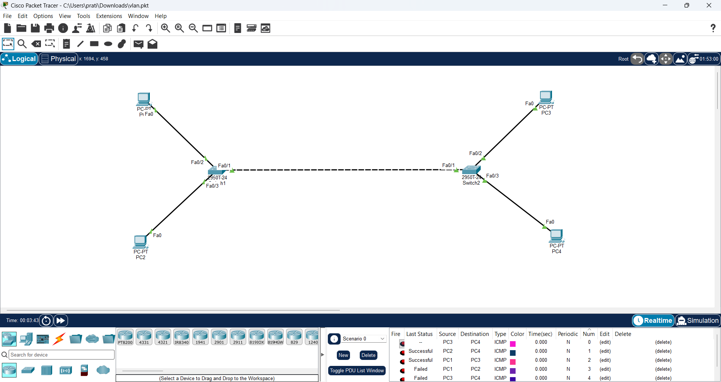

Commands:
enable
configure terminal
vlan 10
name a
exit
vlan 20
name b
exit
interface fa0/2
switchport mode access
switchport access vlan 10
exit
interface fa0/3
switchport mode access
switchport access vlan 20
end
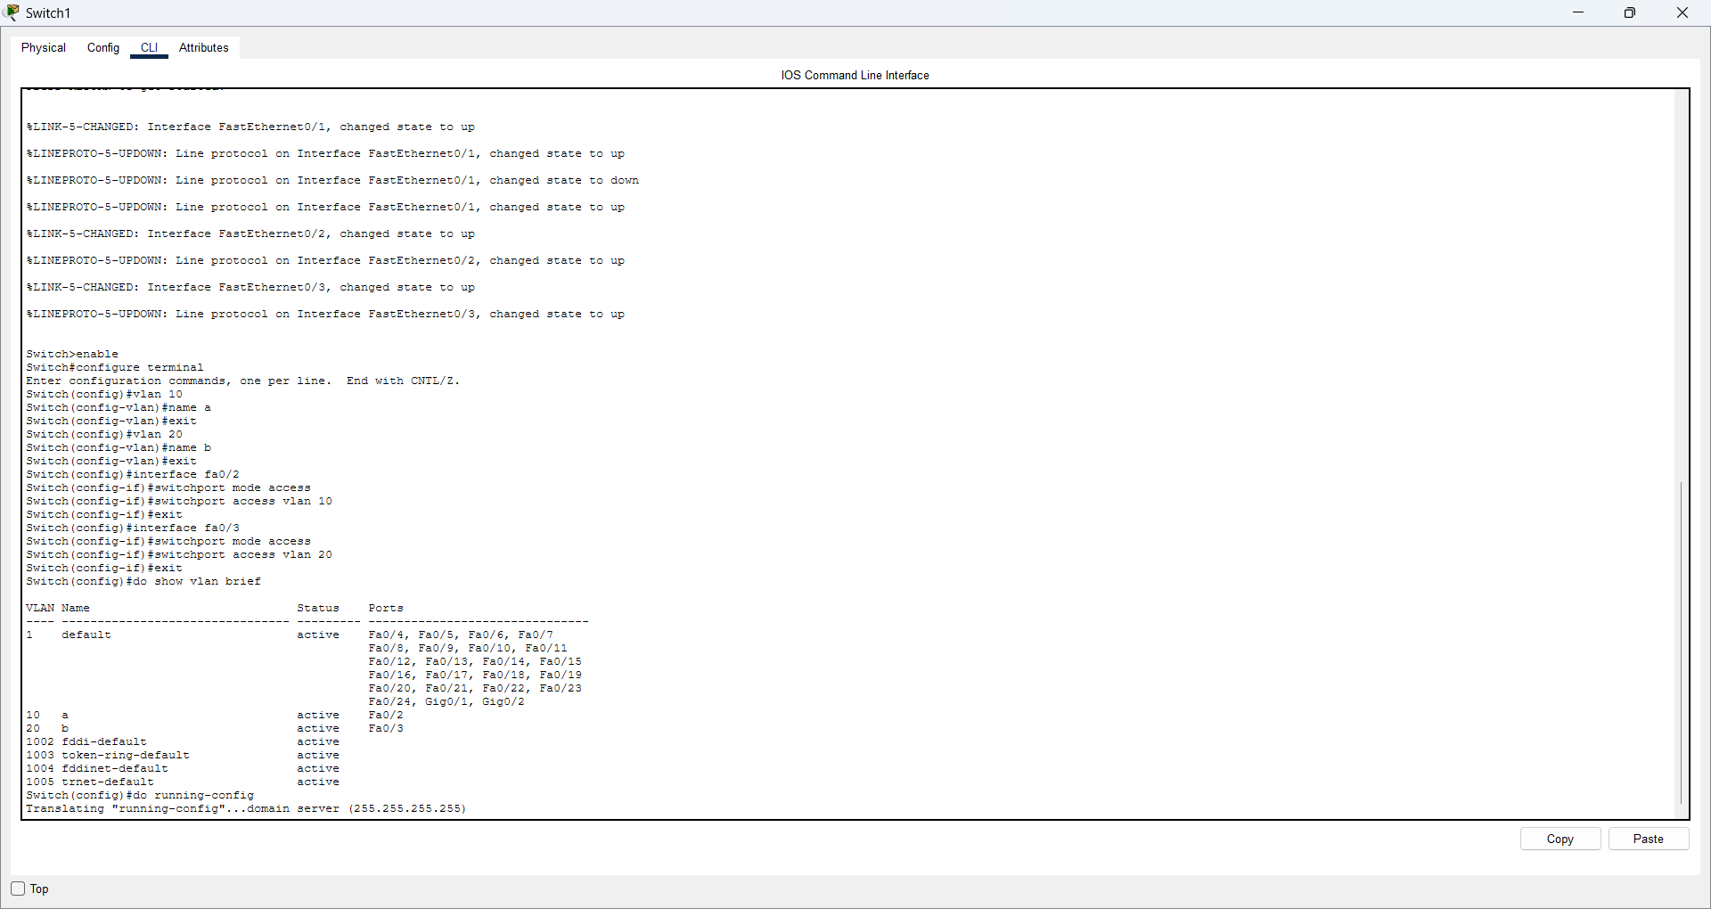

Configure VLAN 10 and VLAN 20 on Switch2
Objective: Create the same VLANs and assign the PC ports.
Commands:
enable
configure terminal
vlan 10
name a
exit
vlan 20
name b
exit
interface fa0/2
switchport mode access
switchport access vlan 10
exit
interface fa0/3
switchport mode access
switchport access vlan 20
end
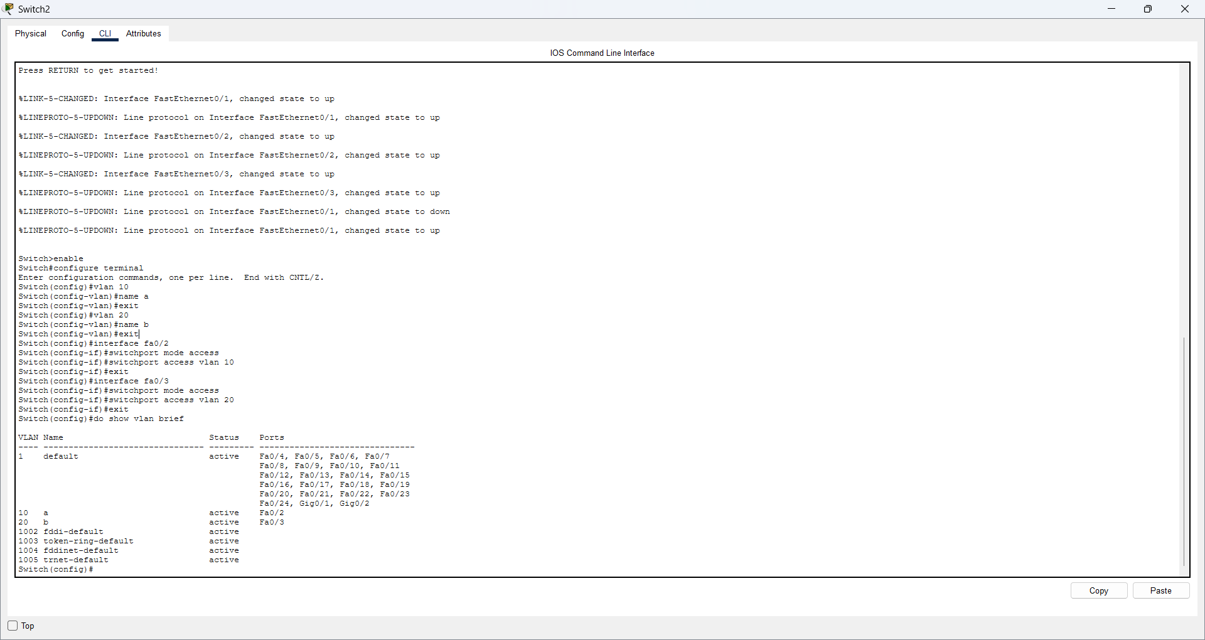

Configure PC IP addresses and test VLAN communication
Commands:
PC1 (VLAN 10): 192.168.10.10 / 255.255.255.0
PC2 (VLAN 20): 192.168.20.10 / 255.255.255.0
PC3 (VLAN 10): 192.168.10.20 / 255.255.255.0
PC4 (VLAN 20): 192.168.20.20 / 255.255.255.0
From PC1 Command Prompt:
ping 192.168.10.20 ← should work (same VLAN)
ping 192.168.20.20 ← should fail (different VLAN, no router)
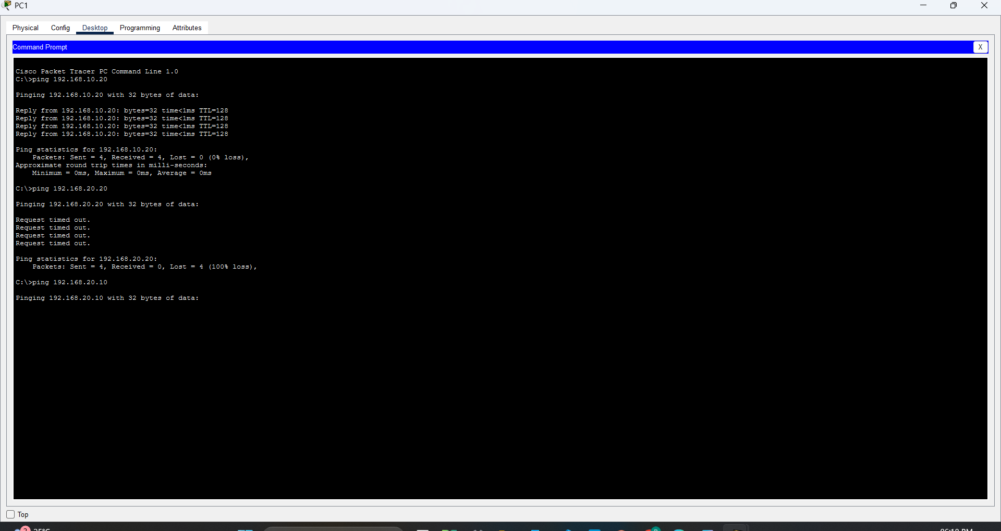

Question 2: VTP
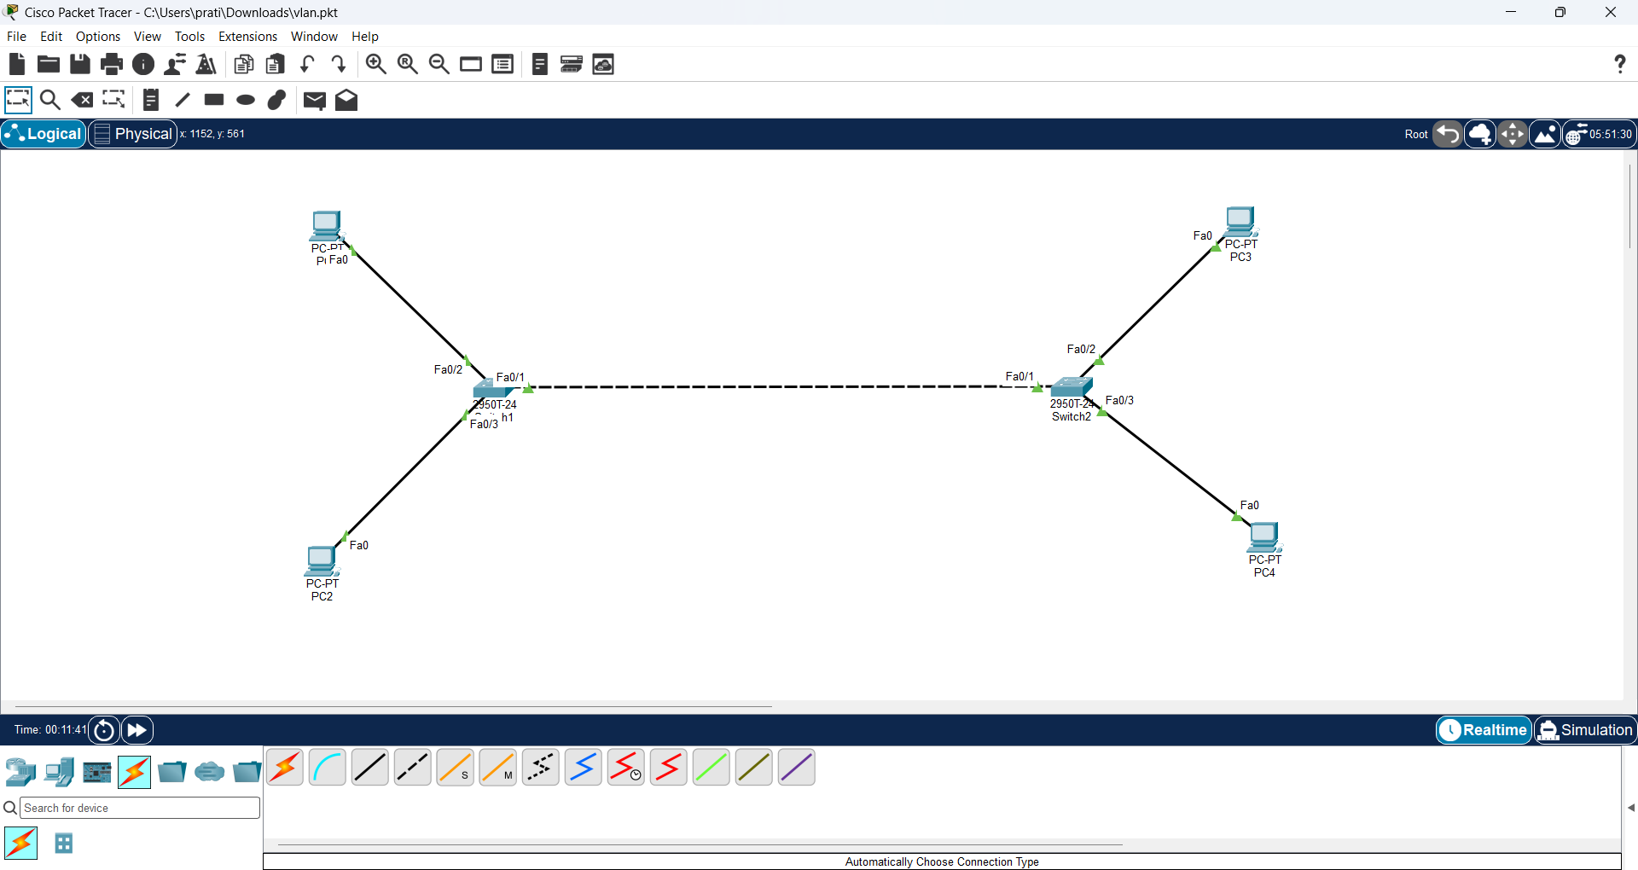
Configure VTP Server and trunk on Switch1
Commands:
enable
configure terminal
interface fa0/1
switchport mode trunk
switchport trunk allowed vlan 10,20
exit
vtp domain company
vtp mode server
vlan 10
name a
exit
vlan 20
name b
exit
end
show vtp status
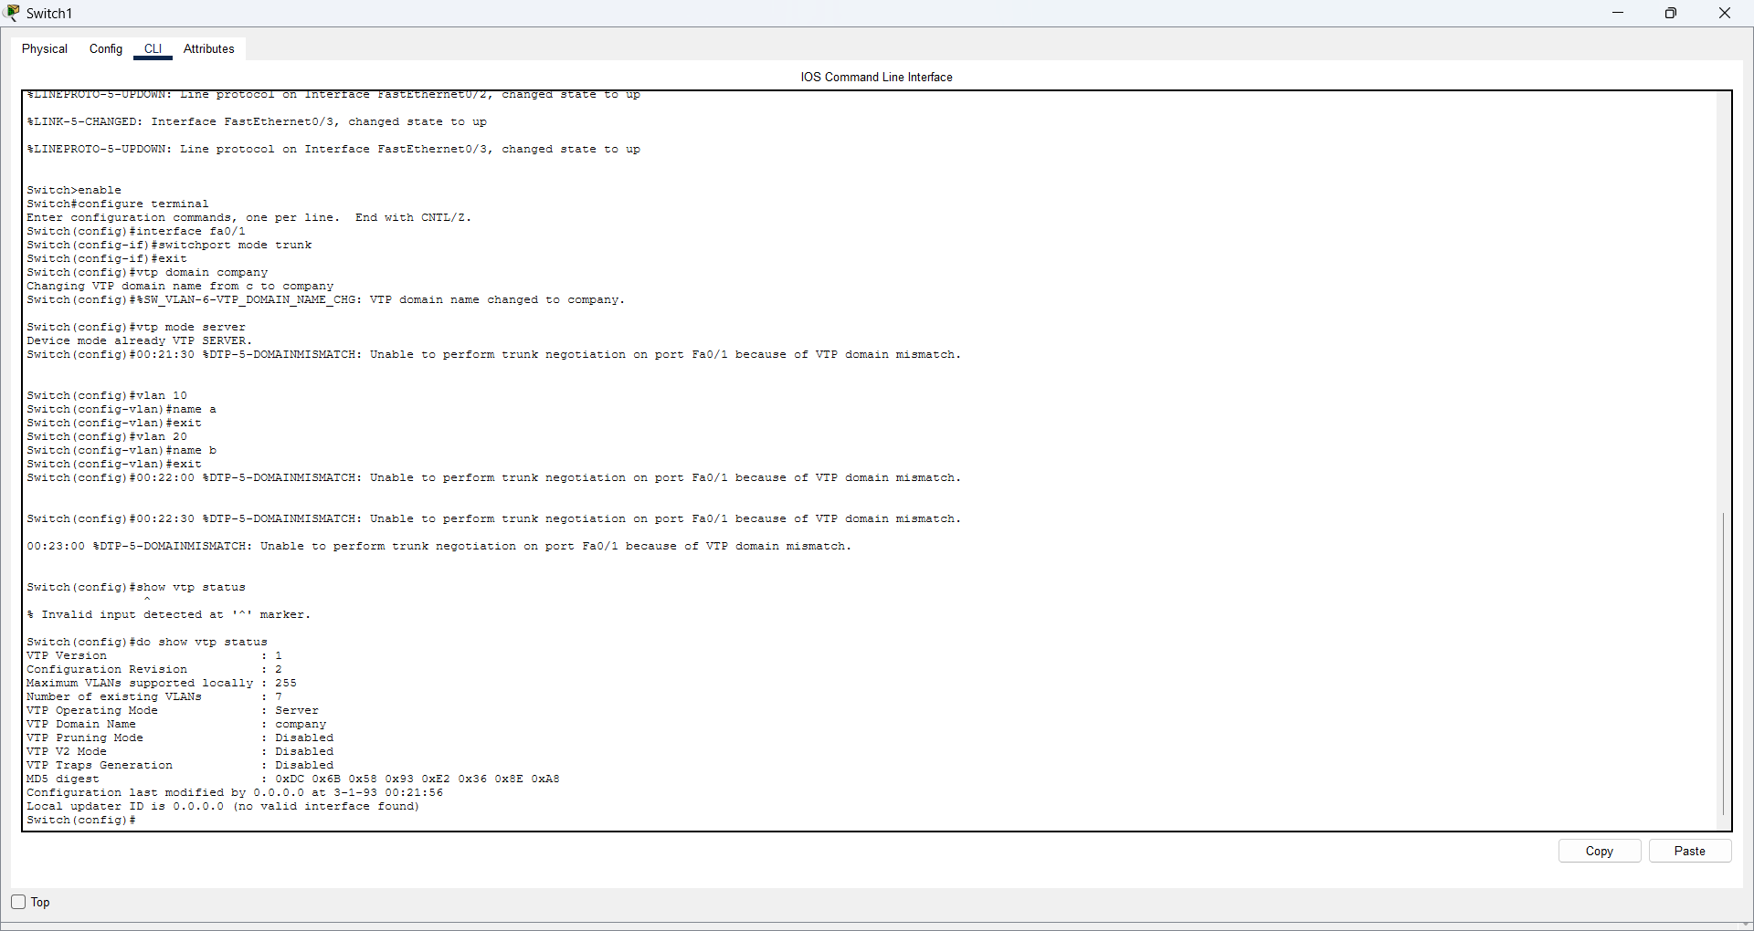

Configure VTP Client on Switch2
Commands:
enable
configure terminal
interface fa0/1
switchport mode trunk
switchport trunk allowed vlan 10,20
exit
vtp domain company
vtp mode client
end
show vtp status
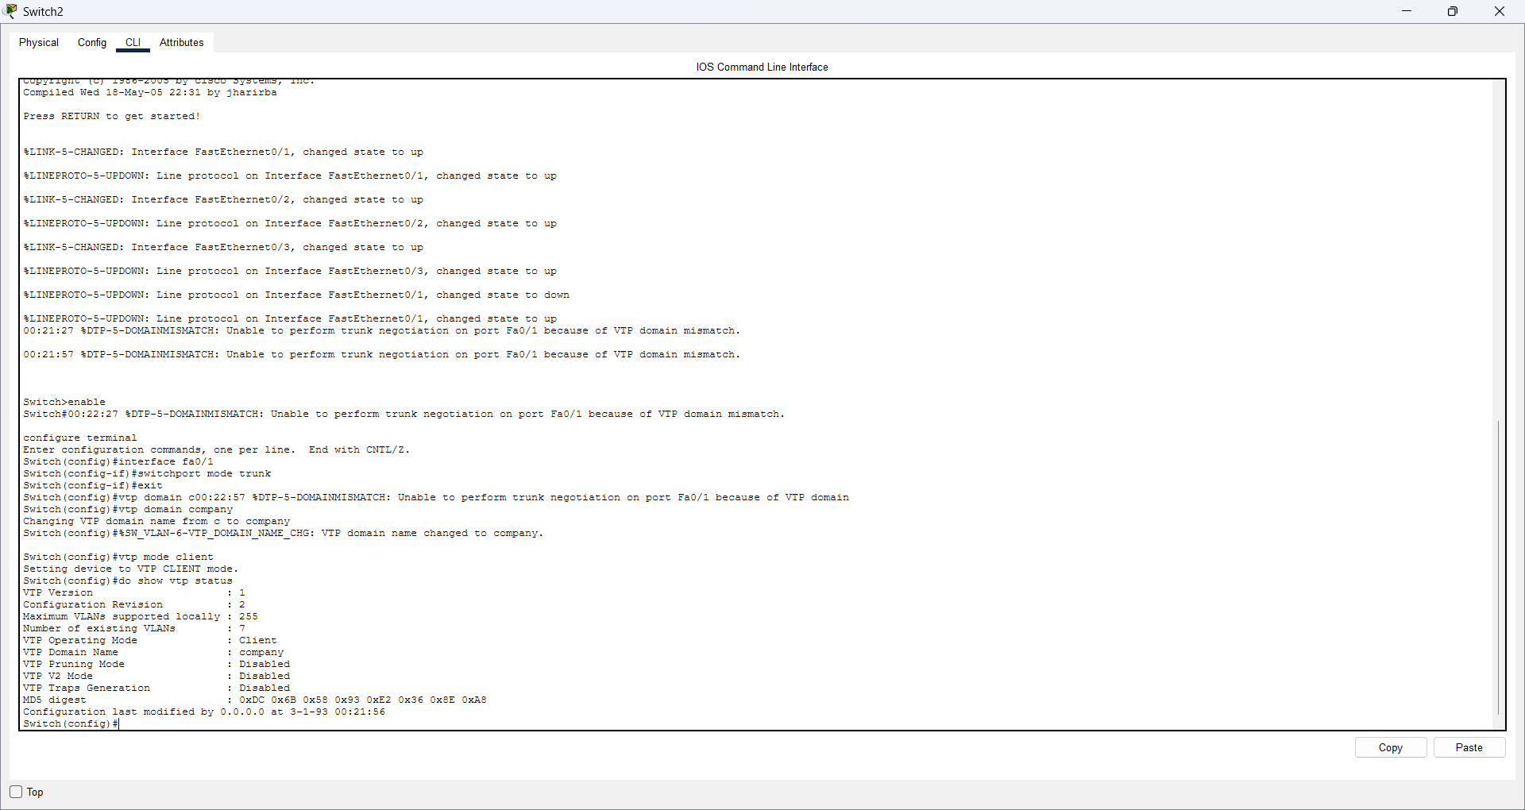
.

Question 7: Verify VTP configuration
Objective: Check that the VTP mode and domain name are correct and that the VLAN information is available.
Commands:
show vtp status
show vlan brief
show interfaces trunk
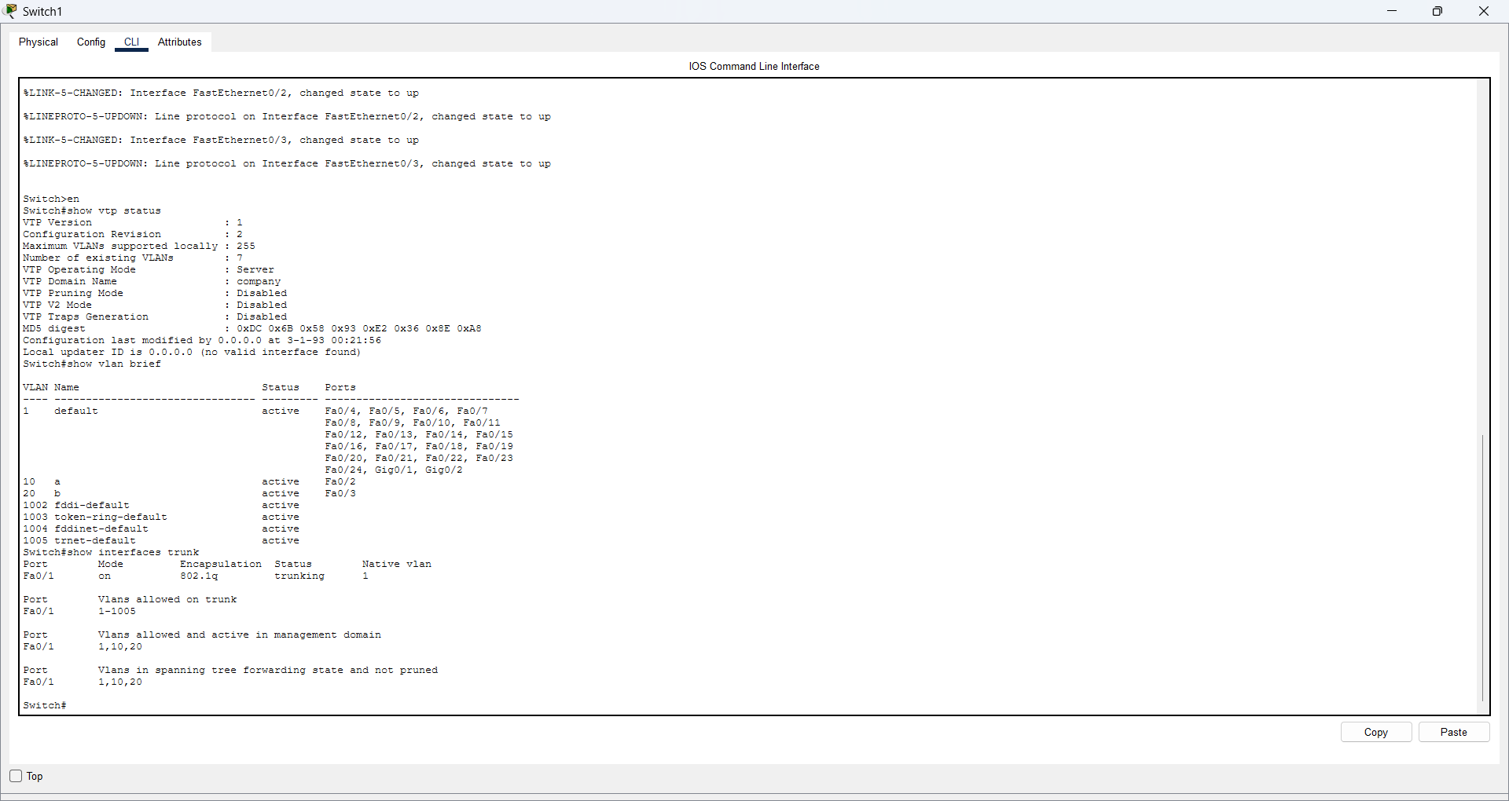

Question 3: STP
Create the STP topology
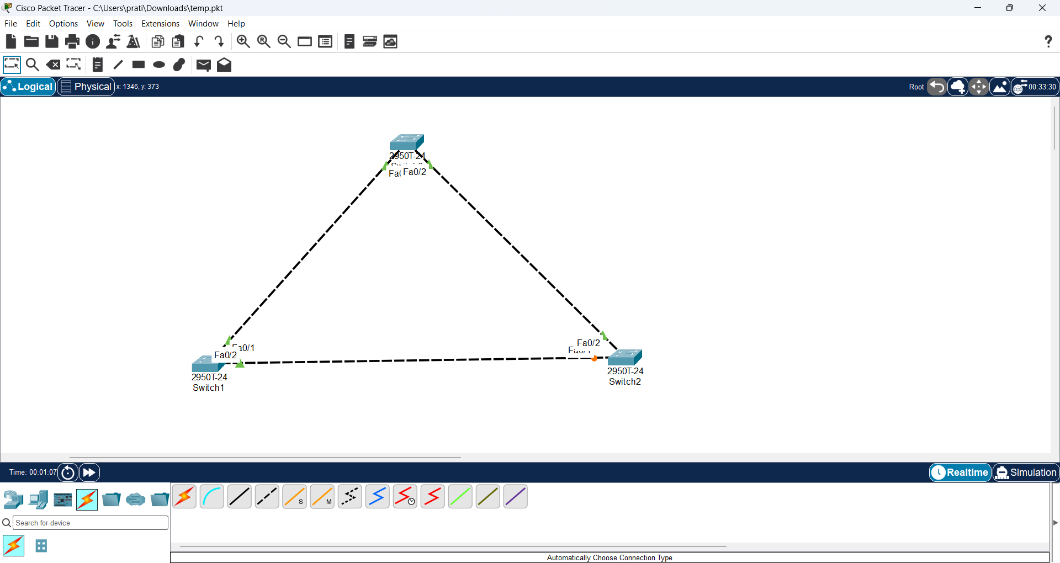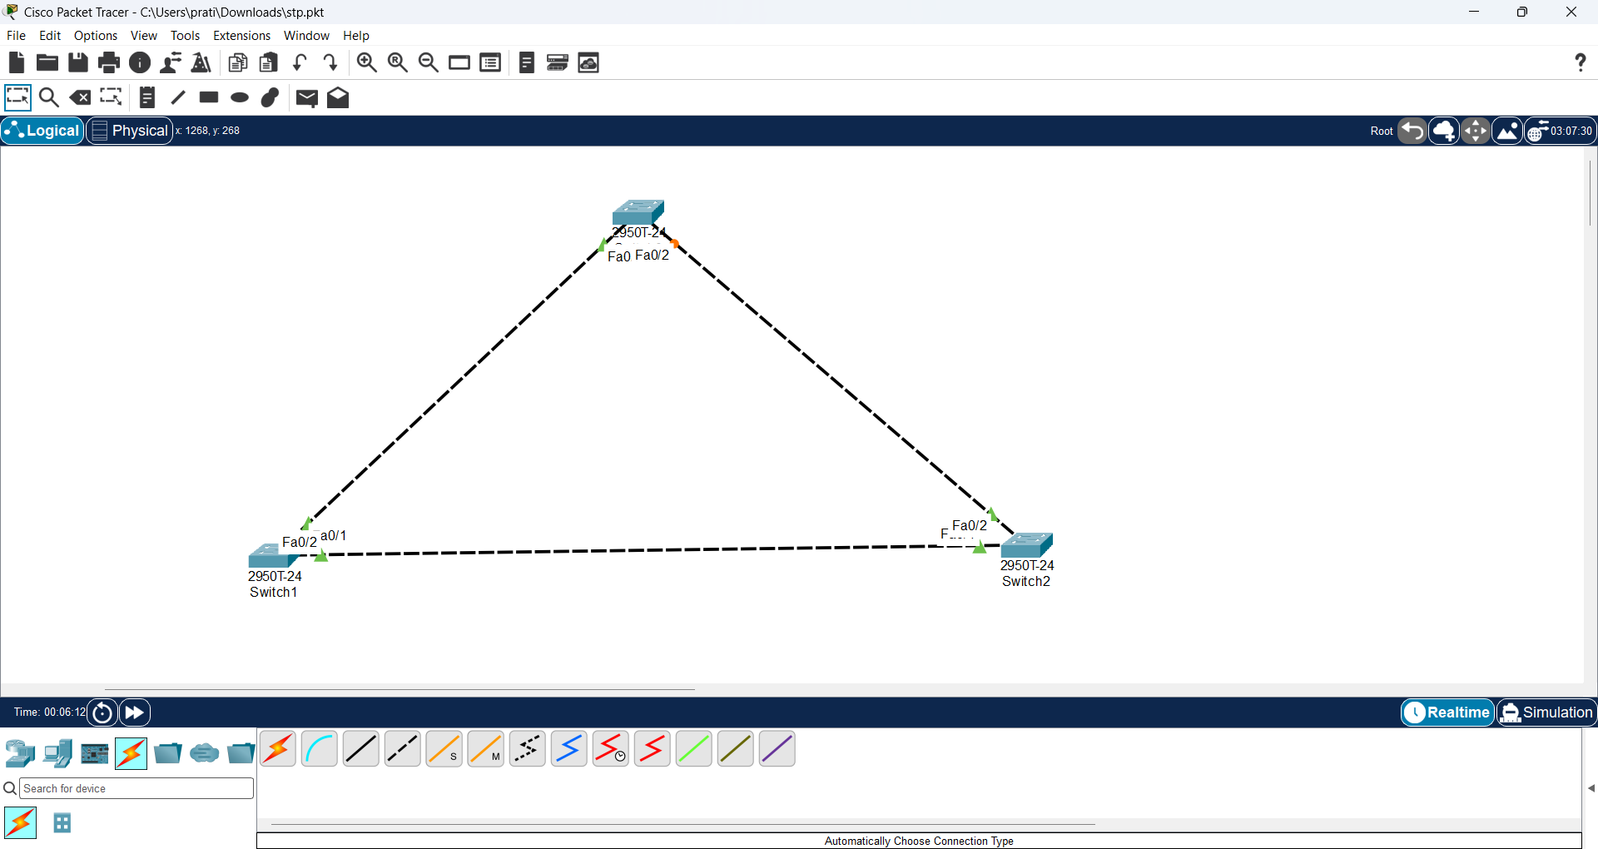

Configure Switch1 as the STP Root Bridge
Commands:
enable
configure terminal
spanning-tree vlan 1 priority 4096
end
show spanning-tree
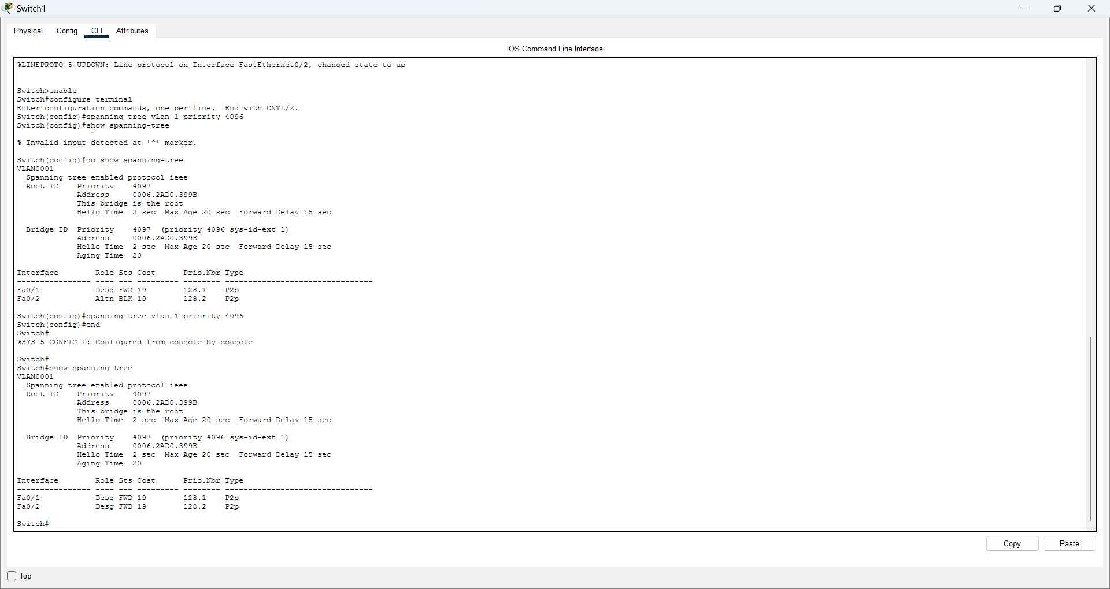

Question 10: Verify the STP result on the switches
Commands:
On each switch:
enable
show spanning-tree

